**Lesson3 APP4:**

**Create an EBS Volume**

**Selecting the volume tab in the EC2 dashboard:**

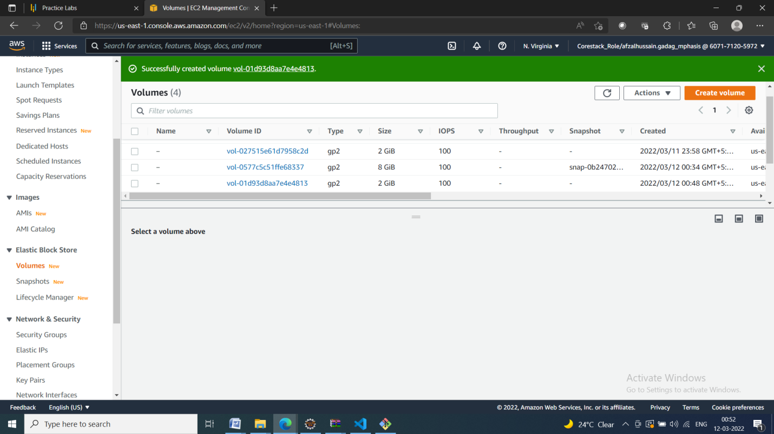

**Creating a new volume by clicking on Create:**

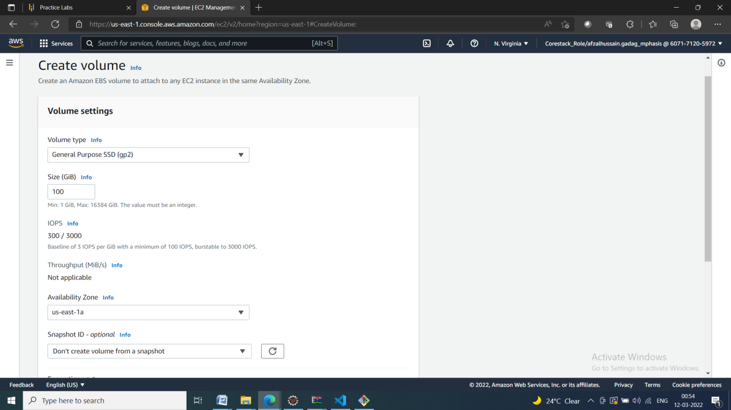

**Selecting the volume type according to the project requirement:**

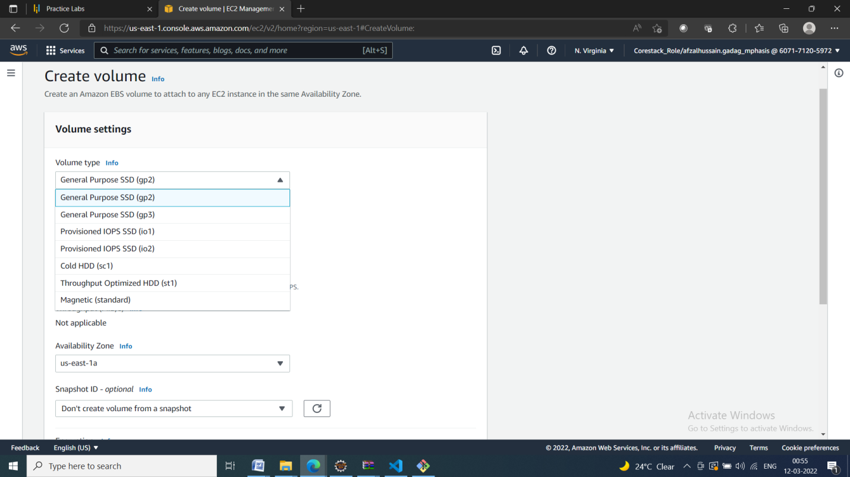

**Creating a new volume by specifying the size and defining the zone:**

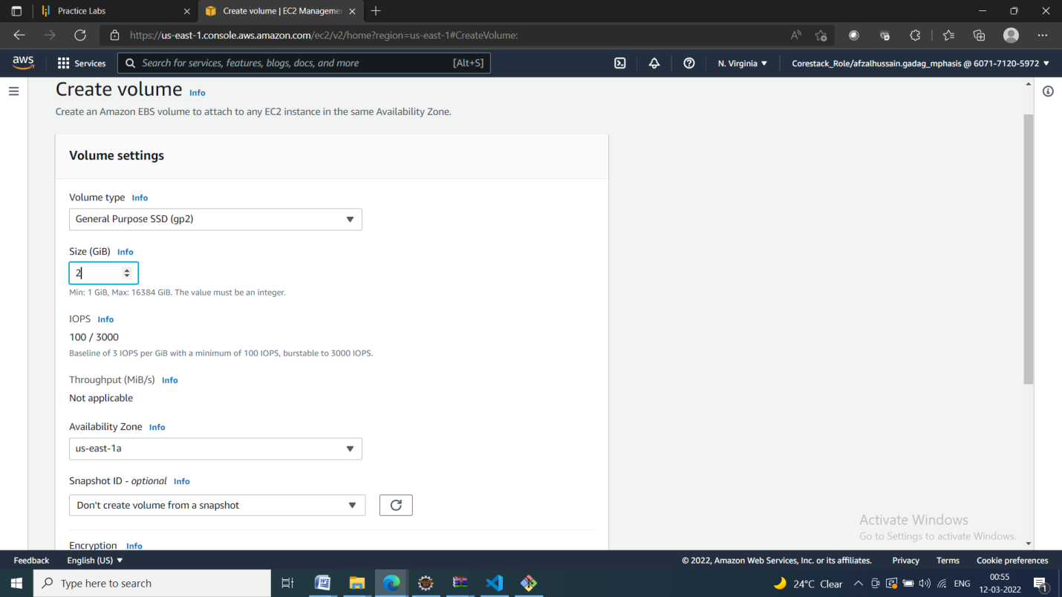

**Verifying the new volume created on the volume console and its availability:**

